Subject line: Have a Clinical Question? DynaMed Plus is Now Available!

[Name of facility] now has access to DynaMed Plus®. Get answers to your clinical questions fast—try it here: [Insert link to DynaMed Plus within your facility].

DynaMed Plus presents critically appraised evidence from more than 500 medical journals in a quick, easy-to-read format designed for use at the point of care.

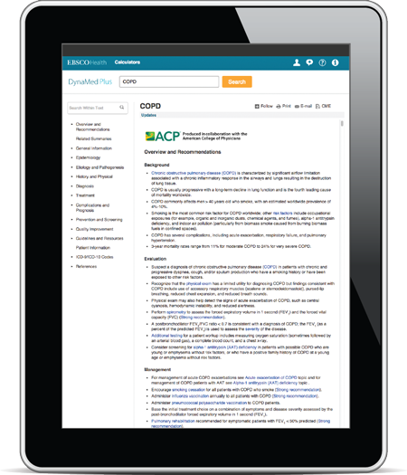
With DynaMed Plus, you will get:

- Content updated 24/7/365
- Concise, evidence-based recommendations with supporting references
- Clinically organized topics designed to get to the answer quickly
- Key points on the background, evaluation and management of a condition presented at the top of each topic
- Synthesized recommendations classified using GRADE
- Internal medicine topics developed and maintained jointly by DynaMed Plus and American College of Physicians (ACP) clinical leadership
- Drug and lab reference content provided by Micromedex®
- Ability to sign up for alerts when a topic or specialty area is updated with new evidence and guidelines
- Off-site access and free mobile app available on Android and iOS platforms.

Where can I find DynaMed Plus?
From the hospital: [link to URL]
From the intranet: [link to URL]
From the library Web page: [link to URL]
For questions, please contact:
[Contact name]
[Email]

