Subject: Access the most popular Harvard Business Review Press book summaries and eBooks

Now Available at [insert company name]. Try it here [insert company portal url]
Access the latest Harvard Business Review eBooks titles critical to your day-to-day research and development needs.
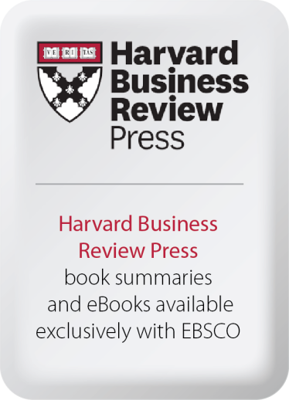
“Our mission is to improve the practice of management in a changing world, and EBSCO helps us achieve this by allowing our content – now in a variety of forms – to be accessed by a broader group of professionals and readers across the globe. The e-book agreement is especially important as more of those readers are consuming content digitally.”

- Sarah McConville, Publisher at Harvard Business Review Press

