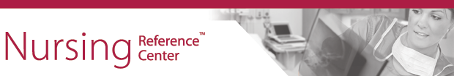

Subject line: Questions about nursing best practices? We’ve got the answer.
Master nursing skills with EBSCO Health’s Nursing Reference Center.
Nursing Reference Center ™ is an evidence-based information resource designed specifically for nurses. You can use Nursing Reference Center to:
- Answer questions about best practices
- Access evidence-based clinical practice guidelines
- Read the latest information about diseases and conditions
- Research care plans
- Access research instruments with descriptions of clinical assessment tools, psychological tests, attitude measures and more.
- Search for point-of-care drug information
- Improve nursing skills with competency checklists
- Earn continuing education credits
- Access patient education handouts
For more information:
http://health.ebsco.com/products/nursing-reference-center/allied-health-nursing

