Directions for use: First copy and paste the suggested subject line into the subject line of your email. Next, copy the entire table below including the header, footer and graphics and paste it into the body of your email. Once you have pasted the table into the body of the email, you can “select all” and center the content, and make edits to the highlighted section toward the bottom to include your contact information or other key points.

Subject Line: Explore all the Nutrition Reference Center has to offer
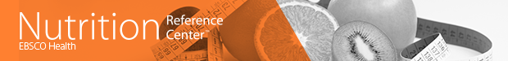
A trusted resource for dietetics practice,
education and research.
Nutrition Reference Center™, the premier point-of-care tool designed specifically for dietitians and nutritionists, provides you with access to …

Unique content on everything from condition specific diets to dietetic skills and practices written by a world-class team of nutritionists and dietitians
A streamlined and user-friendly interface
Customizable patient education handouts to share with patients and caregivers
High-quality continuing education modules for lifelong learning and professional development
A convenient and easy-to-use mobile app
For more information about Nutrition Reference Center or to access the resource now (Insert your librarian’s contact information or a hyperlink to launch the resource here and remove this note).

